EXPERIMENT 4 Date:
Install a C compiler in the virtual machine created using a virtual box and execute Simple Programs.

AIM:
The aim of this experiment is to install a C compiler (GCC) in a virtual machine and to
compile and execute a simple C program successfully.

REQUIREMENTS

Hardware Requirements:
- Computer / Laptop
- Minimum 4 GB RAM (recommended)

Software Requirements:
- VirtualBox or KVM Virtual Machine Manager
- Ubuntu Operating System (ISO file)
- GCC (GNU C Compiler)
- Text Editor (gedit / nano)

THEORY (BASIC EXPLANATION)
A C compiler is a software tool that converts C source code into machine-readable code. GCC (GNU Compiler Collection) is one of the most commonly used C compilers in Linux.

A Virtual Machine (VM) allows us to run an operating system inside another operating system. It provides a safe and isolated environment for learning, testing, and running programs without affecting the host system.

In this experiment, Ubuntu Linux is installed inside a virtual machine. GCC is then installed in Ubuntu to compile and execute a simple C program. This helps in understanding how C programs are developed and executed in a Linux environment.

PROCEDURE:

Step 1: Creating a Virtual Machine
Before installing a C compiler, a virtual machine must be created.
A virtual machine (VM) is software that allows us to run an operating system inside another operating system.

Open VirtualBox / KVM Virtual Machine Manager.
- Create a new virtual machine.
- Allocate required system resources such as RAM and CPU.
- Install an operating system like Ubuntu Linux inside the virtual machine.
- The virtual machine is given a name and saved.
This step is important because all programs will be installed and executed inside this virtual environment instead of the host system.

Step 2: Opening Ubuntu OS in the Virtual Machine
- Start the virtual machine from the virtual manager.
- The Ubuntu operating system boots inside the virtual machine.
- Log in using the username and password.
Now the Ubuntu OS is ready to use for installing software and running programs.

Step 3: Writing a Simple C Program
- Open Text Editor in Ubuntu.
- Type a simple C program. Example:
#include <stdio.h> int main()
{
printf("Hello World"); return 0;
}
- Save the file on the Desktop with the name hello.c.
This step creates a source code file that will be compiled using the C compiler.

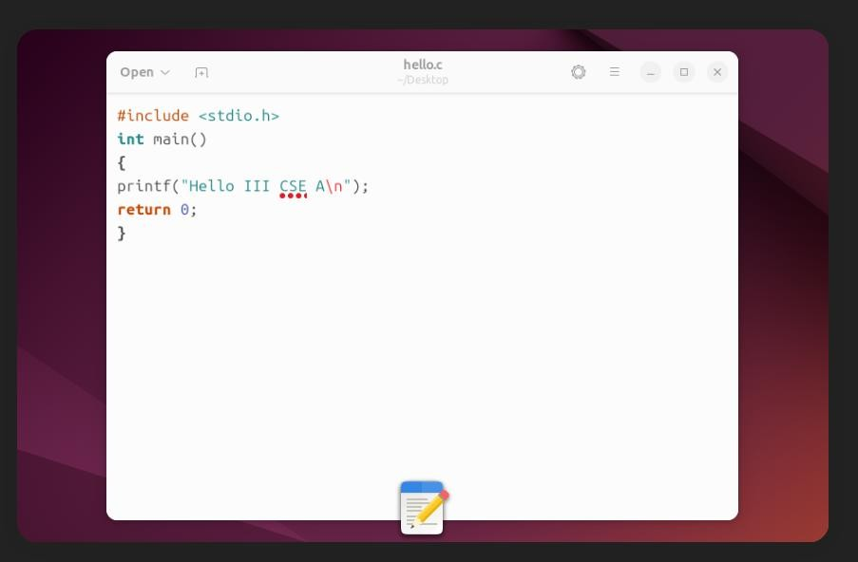

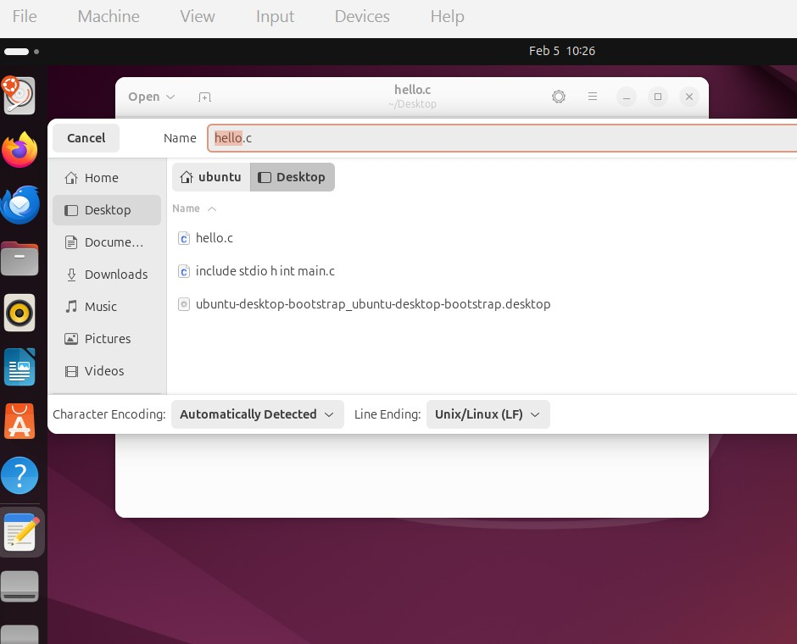

Step 4: Installing the C Compiler (GCC)
- Open the Terminal in Ubuntu.
- Enter the following command:
sudo apt-get install gcc
- Enter the system password when prompted.
- The system downloads and installs GCC.
GCC (GNU Compiler Collection) is required to convert C source code into an executable program.
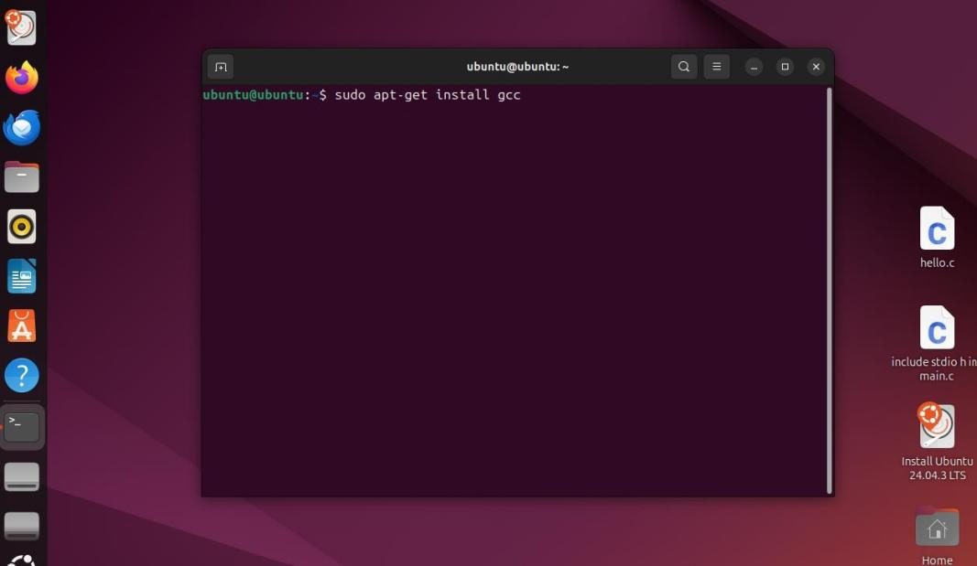

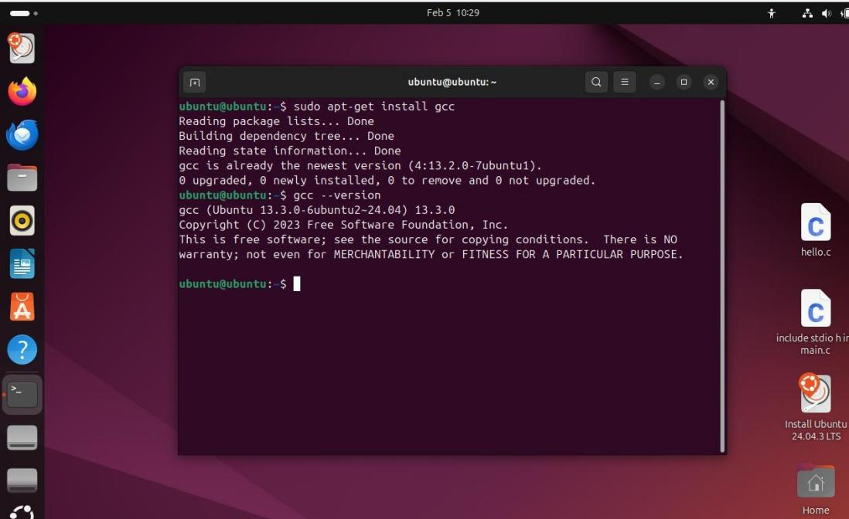

Step 5: Compiling and Executing the Program
- Move to the Desktop directory: cd ~/Desktop
- Compile the C program using:
gcc hello.c -o hello
This command converts the source code into an executable file named hello.
- Execute the program using:
./hello
- The output is displayed on the terminal.
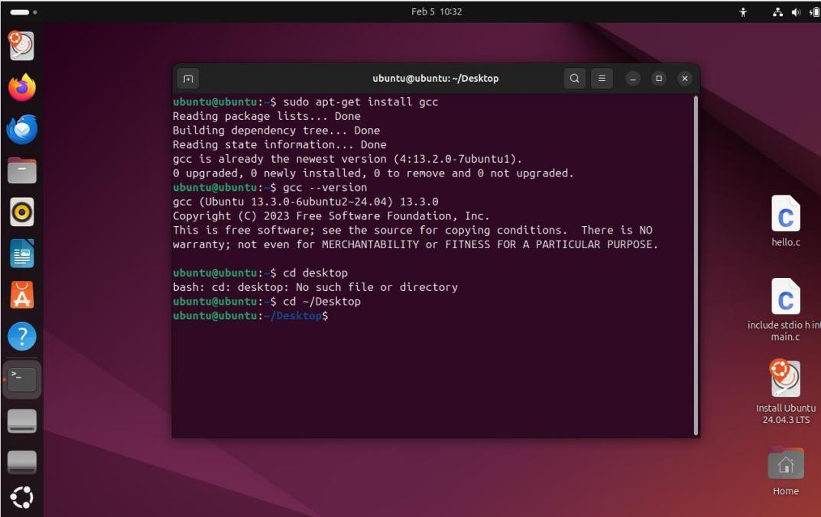
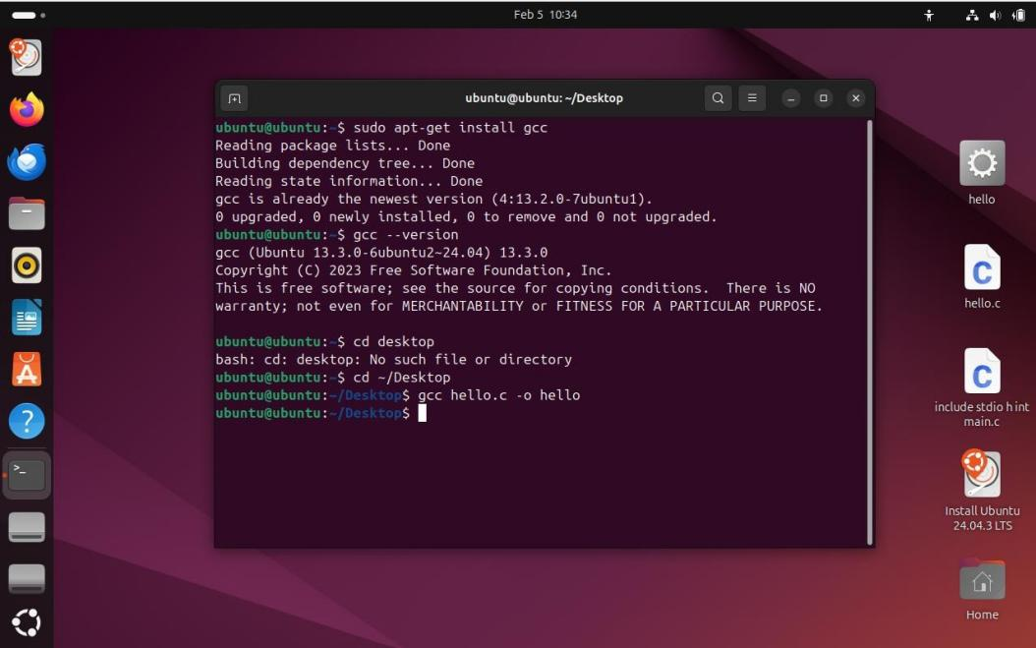

OUTPUT
The message "Hello World" is displayed on the terminal screen.
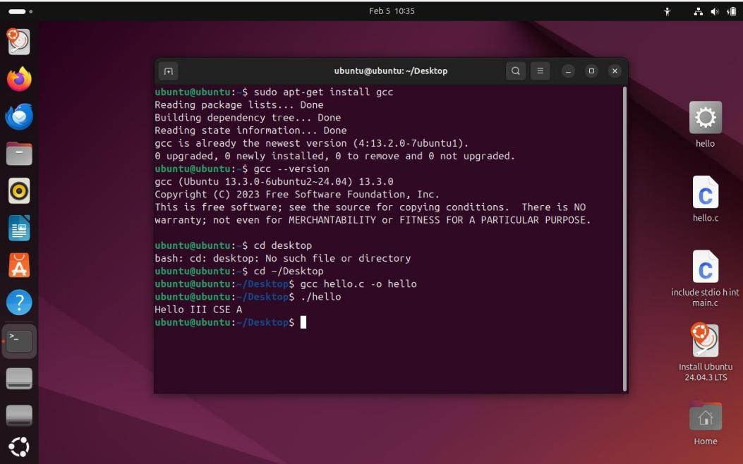

TROUBLESHOOTING / IMPORTANT NOTES (ELABORATED)

GCC: command not found
This error occurs when GCC is not installed. Solution:
- sudo apt-get install gcc
- Permission denied while executing program This occurs when execution permission is missing. Solution:
- chmod +x hello

Virtual Machine running slow
This happens due to low system resources.
Increase RAM, CPU cores, or video memory in VM settings.

Unable to locate package gcc
This occurs when the package list is outdated. Solution:
- sudo apt-get update

Program compiles but does not run
  - Ensure correct compilation command
  - Run the program using ./hello

VIVA QUESTIONS WITH ANSWERS (BONUS)

What is GCC?
GCC is a compiler used to convert C programs into executable files.

Why is a virtual machine used?
It allows us to run an operating system safely without affecting the host system.

What command installs GCC in Ubuntu?
sudo apt-get install gcc

What is the function of main() in C?
It is the starting point of program execution.

How do you compile and run a C program in Linux?
Compile: gcc file.c -o file Run: ./file

RESULT
Thus, the GCC C compiler was successfully installed in the Ubuntu virtual machine, and a simple C program was compiled and executed successfully.

